% assignment 7 part 1 # 2
x=0:.05:2;y=x;
[X,Y]=meshgrid(x,y);
I1=X<1 & Y<1;
I2=X>=1 & Y<1;
I3=X>=1 & Y>=1;
I4=X<1 & Y>=1;
Z=zeros(size(X)); %or Z=X; preallocation step
%%X, Y, Z must have the same dimension
Z(I1)=X(I1).*Y(I1);
Z(I2)=-(X(I2)-2).*Y(I2);
Z(I3)=(X(I3)-2).*(Y(I3)-2);
Z(I4)=-X(I4).*(Y(I4)-2);

surf(x,y,Z); % or surf(X,Y,Z);

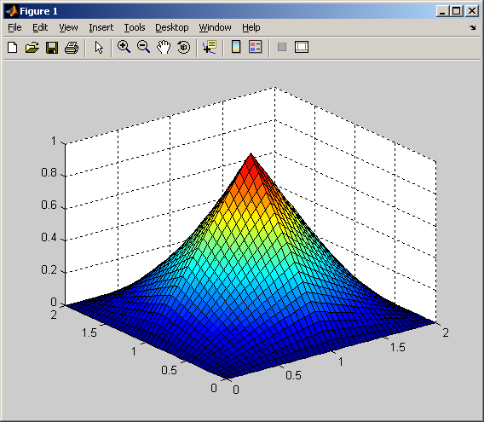
% assignment 7 part 1 # 3/4
function ex7p1_3
n=100:100:3000;
timer=zeros(length(n),4); % preallocation for timer, 4 columns
for i=1:length(n)
timer(i,1)=n(i);
tic;mult_for(n(i));timer(i,1)=toc;
tic;mult_vec(n(i));timer(i,2)=toc;
tic;add_for(n(i));timer(i,3)=toc;
tic;add_vec(n(i));timer(i,4)=toc;
end

plot(n,timer(:,1),n,timer(:,2),n,timer(:,3),n,timer(:,4));
legend('mult\_for','mult\_vec','add\_for','add\_vec');
print -dpng timercompare.png

function A=mult_for(n) % subfunction
A=zeros(n);%preallocation
for i=1:n
for j=1:n
A(i,j)=i*j;
end
end

function A=mult_vec(n)
a=1:n;
A=a'*a;

function A=add_for(n)
A=ones(n); %preallocation
for i=1:n
for j=1:n
A(i,j)=i+j;
end
end

function A=add_vec(n)
a=ones(1,n);b=1:n;
A=a'*b+b'*a;
